**My Wishlist**

Hi, PPTI 16 fellows. In purpose to practice on how you must think when creating a program in a computer using array with all of the previous material that we have learn, this practice case will help you to translate from algorithm and procedures to source code in C programming language. Hope this helps!

In this case we wan you to make a program that store all of your item that you want to buy in the future.

**\*Notes: you will need to find about strcpy() and getchar() function in this case \***

When the program has been run, here’s the program flow that you need to create:

* In the beginning of program’s execution, it will show the **wishlist table** with no item in it. Then it also shown **two menu option,** **Add Item** and **Exit**.

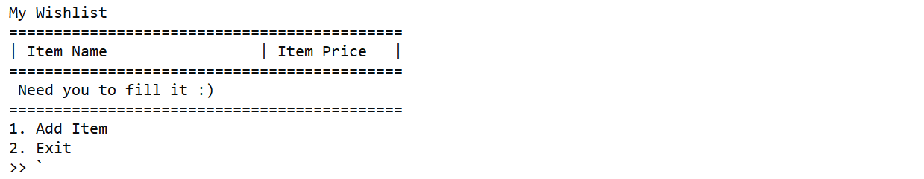

**Figure 1 Main menu**

* If user inputs **Menu 1** (Add Item), do:
  + - **Ask** user to input:
      * **Item name**
      * **Item price**
    - Then, Store the inputted **item name** and **price** into **arrays**. Assign **20** as **maximum** number of item that user can input.

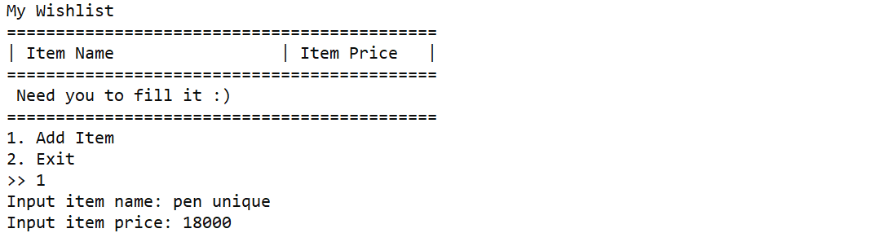

**Figure 2 Add Item Menu Input**

* + - Then, the program will automatically go back to the main menu and **show** the **list of items** that user already added.

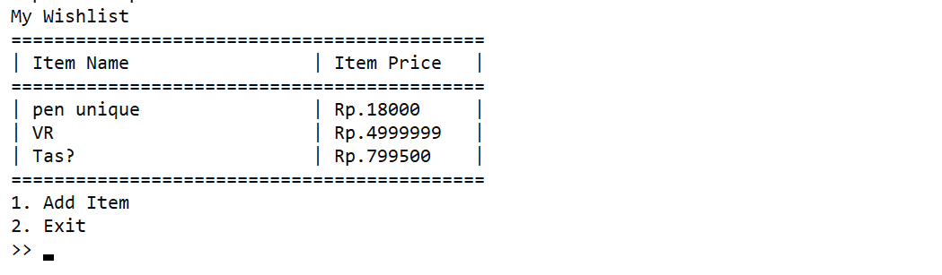

**Figure 3 Main Menu after several inputs**

* If user input **Menu 2** (Exit), do **print** “Thank you” **message** and **close** the **application**.

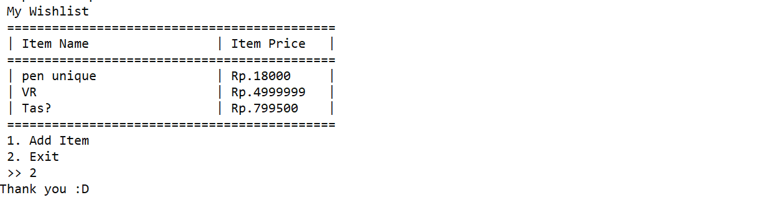

**Figure 4 Input exit menu**

* + Otherwise, do **print** “You must input valid menu number!” **message**.

**Figure 6 Input invalid menu option number**

* The **application** will be **closed** only if user **picks menu 4** (Exit), otherwise the application will show **main menu** repeatedly.